**EXPERIMENT – 2**

**Aim:**

To learn the vi Editor by doing various tasks:

1. **Create a file named testVI1.txt in the CAD folder created last time. Type minimum of 2 paragraphs of 10 lines at least.**

Created CAD folder

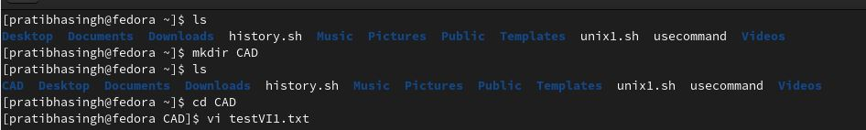

Created testVI1.txt file in the CAD folder

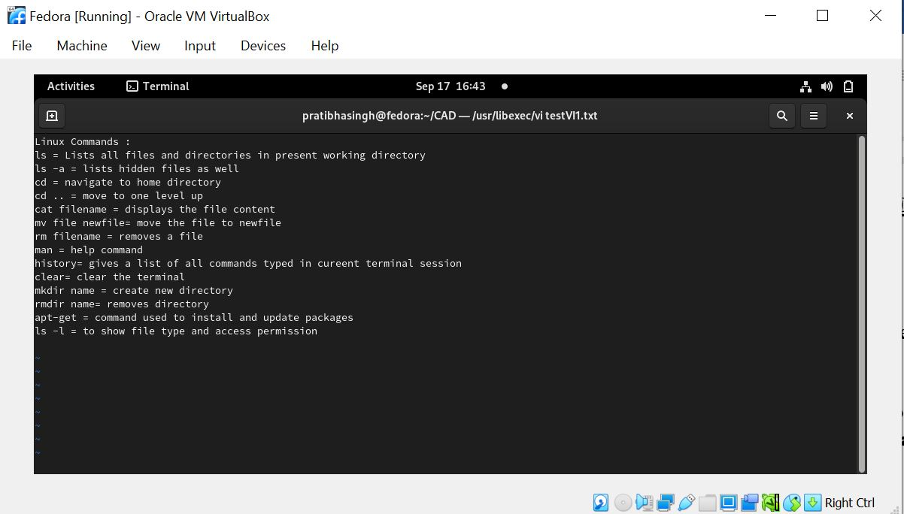

1. **Use the cp command to create the copy of the file.**

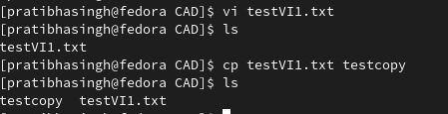

1. **Try out opening the second file in read only mode and delete it later with the help of rm command**

Before changing the user preference:

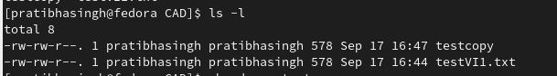

After changing the user preference:

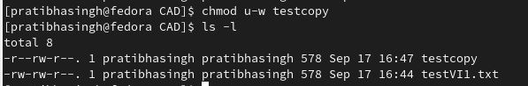

Deleting the file with the help of rm command:

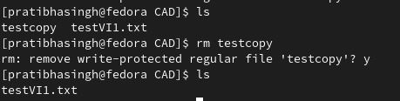

1. **Inside the file**
2. Different ways to come out of the file:



1. Various Navigation keys used:
2. $ is used for cursor at the end of line
3. ctrl a is used to move to the start of the line
4. ctrl e is used to move to the end of the line
5. o is used for new line from insert mode
6. (,) is used for moving across lines.
7. Deleting inside the file:

1. dd deletes the line

2. x key deletes the letter the cursor is pointing

3. ndd deletes n number of lines from the cursor position

1. Insert and append modes

* *Append single line text* - $ echo “i am now appending a line by using echo command”>>newfile.txt



newfile.txt

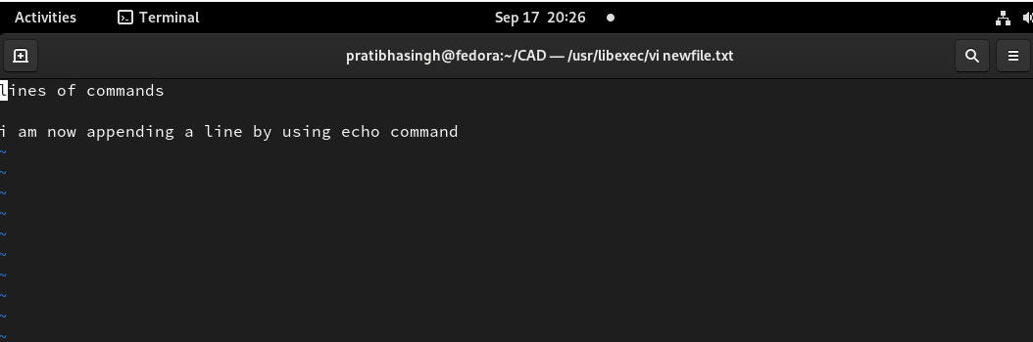

* *Append Multiple lines* - $ cat>>newfile.txt

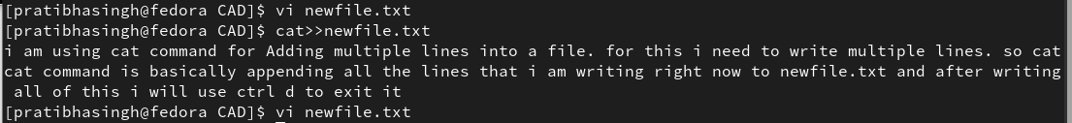

newfile.txt

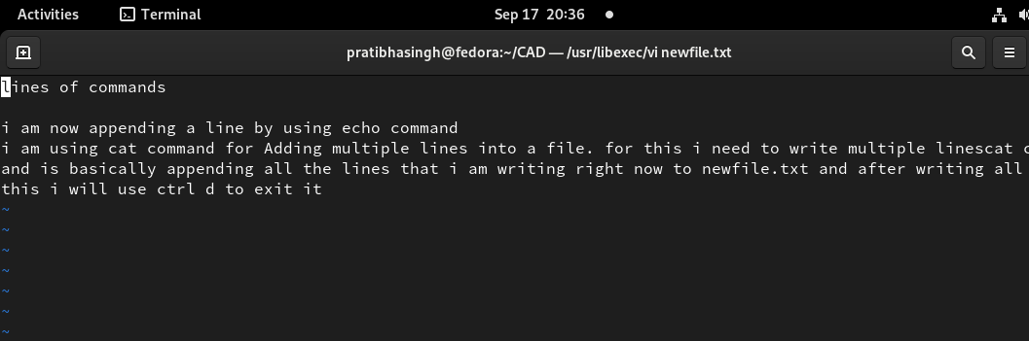

* *Append text from another file* - $ cat testVI1.txt>>newfile.txt

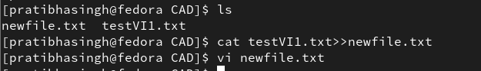

newfile.txt

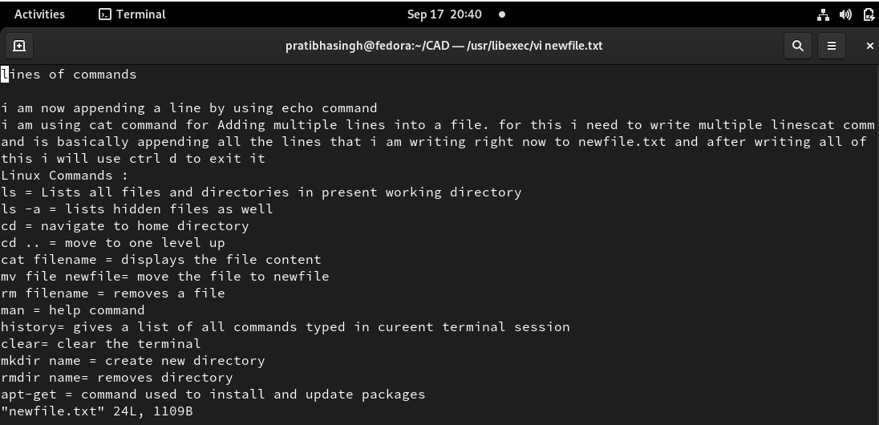

1. Copy paste the current lines

***Copy - yy***

* The command yy (yank yank) is used to copy a line. Move the cursor to the line you want to copy and then press yy
* In this screenshot the line at which my cursor is present is copied by me with yy key

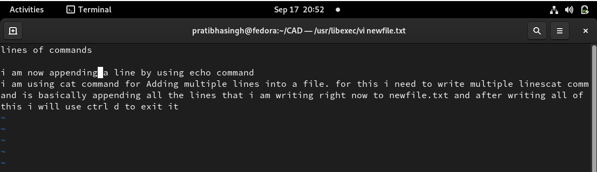

***Paste – p***

* The p command paste a copied or cut content after the current line
* In this screenshot I am using p key for pasting the line that I have copied in the previous screenshot

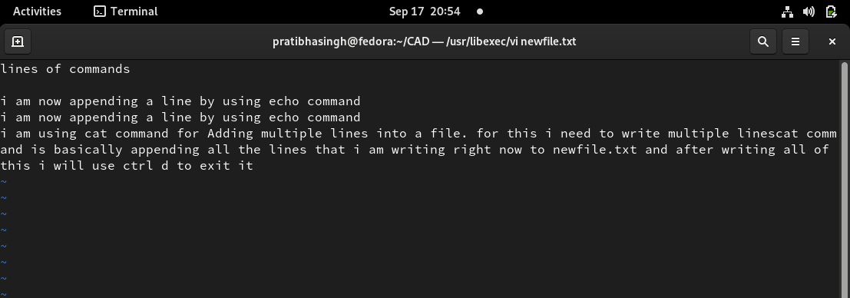

1. Various options related to moving between the paragraphs etc.

